
VILNIUS GEDIMINas Technical university
Faculty of Electronics
department of Electrnics systems

Machine Learning
Practical work 5
Authors: Kirill Postrehan, EDIfu 24/1
Lecturer: Dr. Olusola Oluwakemi Abayomi Alli

VILNIUS 2026
Introduction:
In this practical work I will apply my knowledge of data splitting and experiment with different number of hidden units, activation and functions. The results of training (train_acc, test_acc and loss curve) will be stored and later on plotted.
Analysis & visualizations:
First things first, I split the preprocessed dataset we got in the end of previous lab into 80 % of training data and 20 % of testing data:
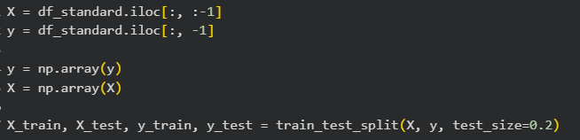
Then the task was to experiment with different options and see which option performs better.
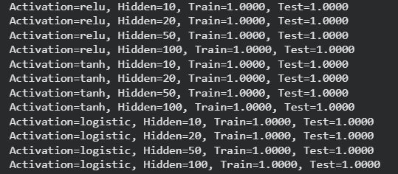
We see here that all options perform great and, in my opinion, the best option is the simplest one where number if hidden layers is equal to 10. I think so because high complexity of model for this task is redundant and requires more computational power.
So, after that I need to plot the loss curve for each option I used during the experiment:
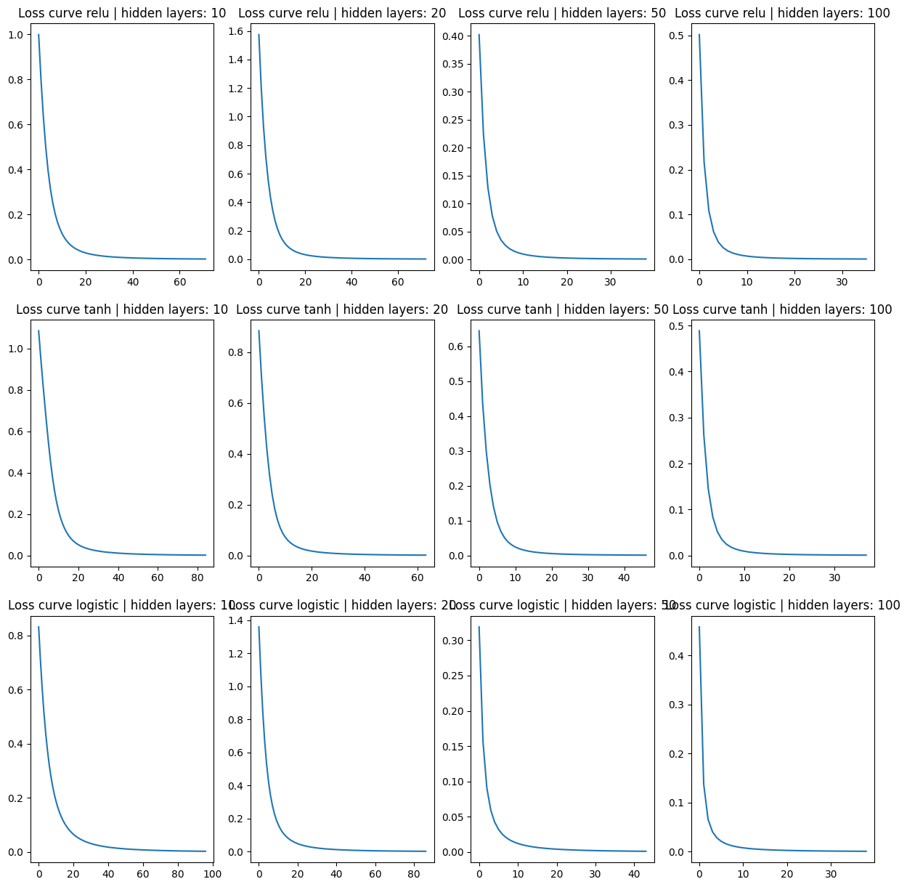
Finally, I can compare the train and test accuracy for all options:
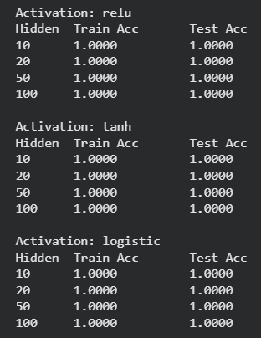
Conclusion:
In this work, several MLP configurations with different hidden units and activation functions were tested. After comparing training and testing accuracy, it was observed that all models performed well, but the simplest model with 10 hidden units provided sufficient performance while requiring less computational resources.

